**AIM:**

To implement Heap Sort in C to sort a list of elements in ascending order.

**📌 ALGORITHM OVERVIEW (Heap Sort):**

1. Build a **Max Heap** from the input array.
2. Swap the first (maximum) element with the last.
3. Reduce the heap size by 1 and **heapify** the root.
4. Repeat until the heap size is 1.

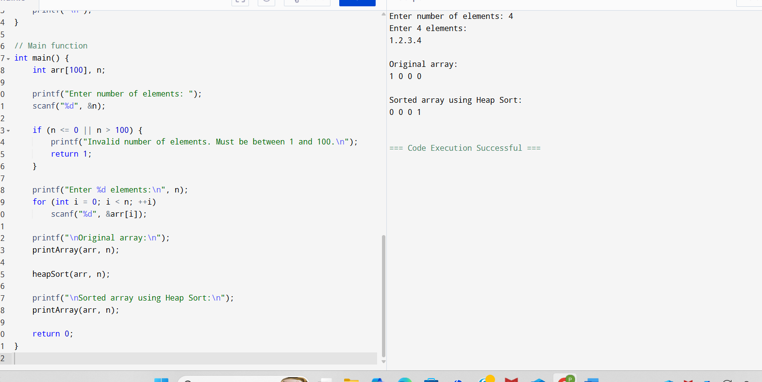

**SAMPLE OUTPUT:**

Enter number of elements: 6

Enter 6 elements:

55 23 87 12 34 78

Original array:

55 23 87 12 34 78

Sorted array using Heap Sort:

12 23 34 55 78 87